# Portfolio Building

Now that we have the weights assigned for each period, we can now build a covariance matrix between the chosen assets.

This can be done by first weighting the returns of the chosen asset class for each hike period by the corresponding weights. After that we can calculate the covariance and correlation matrix of the assets.

The annual covariance matrix for all the asset classes can be found below:

|  |  |  |  |  |  |
| --- | --- | --- | --- | --- | --- |
|  | Energy | Telecom | Health | Oil | Gold |
| Energy | 0.0016 | 0.0004 | 0.004 | 0.0009 | 0.0002 |
| Telecom | 0.0005 | 0.0010 | 0.0006 | -0.0001 | -0.0001 |
| Health | 0.0005 | 0.0006 | 0.0010 | -0.0002 | -0.0001 |
| Oil | 0.0008 | -0.0002 | -0.0002 | 0.0053 | 0.0004 |
| Gold | 0.0002 | -0.0001 | -0.0001 | 0.0004 | 0.0010 |

The correlation matrix between the asset classes are as below:

|  |  |  |  |  |  |
| --- | --- | --- | --- | --- | --- |
|  | Energy | Telecom | Health | Oil | Gold |
| Energy | 1 | 0.39 | 0.36 | 0.3 | 0.12 |
| Telecom | 0.39 | 1 | 0.63 | -0.07 | -0.08 |
| Health | 0.36 | 0.63 | 1 | -0.09 | -0.09 |
| Oil | 0.3 | -0.08 | -0.09 | 1 | 0.19 |
| Gold | 0.12 | -0.08 | -0.09 | 0.19 | 1 |

## Mean Variance Efficiency (MVE)

Given the covariance matrix and the returns of the assets, the Sharpe ratio of the MVE portfolio can be calculated. This Sharpe ratio can be used along with a user defined standard deviation to get the returns of the portfolio.

$$Sharpe Ratio_{MVE}={\left({\overline{R}}^{e}\right)}^{'} Σ {\overline{R}}^{e}$$ where ${\overline{R}}^{e}$ 
 is the average excess returns of the assets $Σ$ 
 is the covariance matrix of the assets

The annual Sharpe ratio of the Mean variance optimized portfolio is **1.554**

## Weights calculation

To come up with the weights of the assets, an accepted return must be chosen. This will be based on client’s propensity for risk. At this point, we choose the return of the portfolio as **23%**. This would lead to an approximate standard deviation of **15%**

For the calculating the weights(w), we need to use come up with the objective function, which is to minimize variance, given the return (m).

*min $\frac{1}{2}w'Σ w-k(w'{\overline{R}}^{e}-m)$*

If we first order differential w.r.t w and set it to 0 to minimize

$Ωw-k{\overline{R}}^{e}$ = 0 => $w^{MVE}=kΩ^{-1}{\overline{R}}^{e}$

If we calculate k using the assumed return, then the weights of the assets come out as:

|  |  |  |  |  |
| --- | --- | --- | --- | --- |
| Energy | Telecom | Health | Oil | Gold |
| 1.47 | 2.07 | 0.83 | 1.11 | -0.018 |

To make the sum of weights add up to 1, we can borrow at risk free rate accordingly.

# Short Term Strategies

Apart from the asset allocation which has been done using the various asset classes, short term strategies can be used to increase the alpha of the portfolio allocation. Two short term strategies have been identified:

* Volatility changes - Long 1-year Tbill, Short twice the 10-year treasury and Long 20-year treasury
* Credit changes – Long BBB rated corporate bonds and short AAA rated corporate bonds

## Historical Performance

The Sharpe Ratios of the 2 strategies in the various rate hike periods are as below:

|  |  |  |
| --- | --- | --- |
| **Period** | **Volatility Strategy** | **Credit Strategy** |
| 1994-1995 | 0.592 | NA |
| 1999-2000 | 0.147 | 0.709 |
| 2004-2006 | 0.737 | -0.05 |
| Recession | -0.46 | 0.41 |
| Current Period | 0.09 | -0.81 |

As can be seen from the historical data, the Volatility strategy has done the best consistently during the rate hike periods.

## Correlation

The correlation further proves that this strategy does well during the rate hike periods.

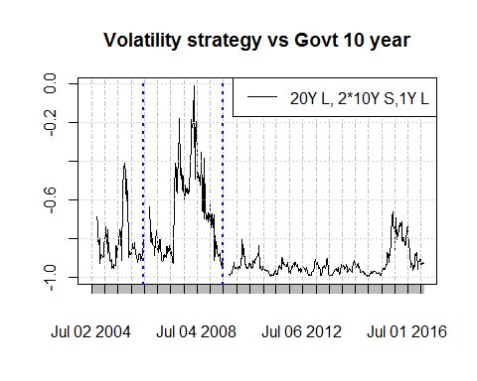

This is explained by the presence of